

Database System Project

Spring-2025 Department of Computer Science

Class 2nd Semester **7M**

Submitted By: Submitted To:

**Zainab Khan Professor**

**Roll NO: F24BDOCS1M01252 Usman Ghani**

1. Introduction

1.1 Background

This project is centered on the development of a **normalized relational database system** to effectively manage academic and organizational data related to **universities**, **professors**, and their **affiliated organizations**.

Currently, many educational and research institutions rely on **manual processes** or **non-optimized spreadsheet tools** to maintain these records, which often leads to:

* **Data redundancy**, **Inconsistencies**
* **Limited scalability** and **Higher risk of errors and data loss**.

1.2 Goal

The primary objective of this project is to **design and implement a relational database system** that capture and organize the following core elements:

* A detailed **catalog of universities**, including key institutional information
* Records of **professors and their affiliations** with specific universities
* Information on **external organizations** with which professors are connected

1.3 Requirements

The system must support the following key functionalities:

* **Store** and **retrieve** university data (name, short name, city)
* **Manage** professor records and their university affiliations
* **Track** organizations and their respective sectors
* **Link** professors to organizations with defined roles
* Enforce **data integrity using foreign key constraints**
* Support CRUD operations for all entities
* Allow complex SQL joins for reporting and analysis

2. Functional Description

2.1 Method of Use

The system will be utilized by the following user groups for various operational and analytical purposes:

* **University administrators** – to manage and update professor affiliations with universities and external organizations
* **Academic researchers** – to analyze patterns of institutional collaboration and academic partnerships
* **IT personnel** – to oversee system maintenance, ensure data integrity, and manage regular backups

3. Entity Data Model

### ****Diagram****

### C:\Users\silicon\Downloads\WhatsApp Image 2025-06-03 at 9.28.02 AM (1).jpeg

### ****Description****

The database is structured around four main entities:

* **Universities** – Stores university names, short names, and locations
* **Professors** – Contains personal details and links each professor to a university
* **Organizations** – Holds information about various external organizations
* **Affiliations** – A junction table that connects professors to organizations, including their specific roles

Each professor is associated with a university via the university_shortname field, and their connections to organizations are managed through the Affiliations table.

4. Schema Screenshots

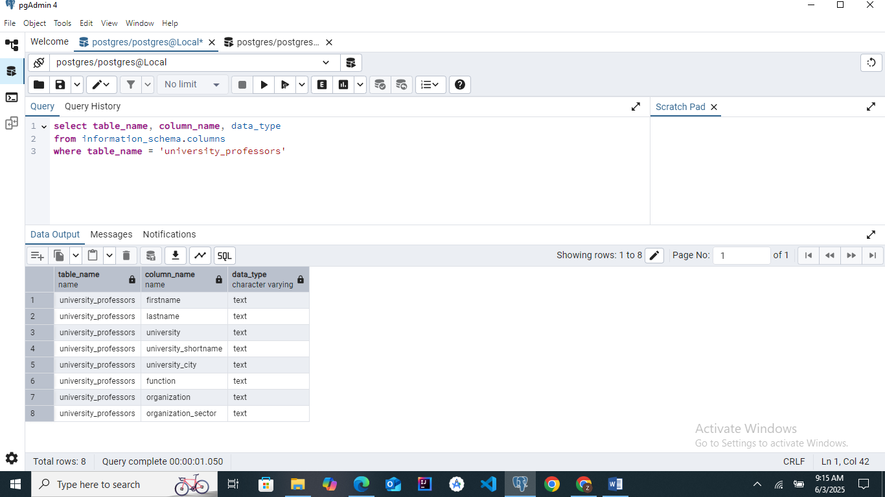

5. Frontend Screenshots

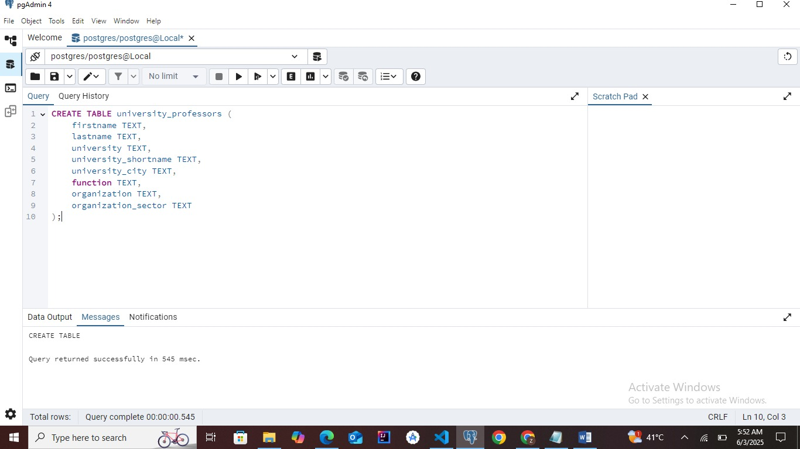

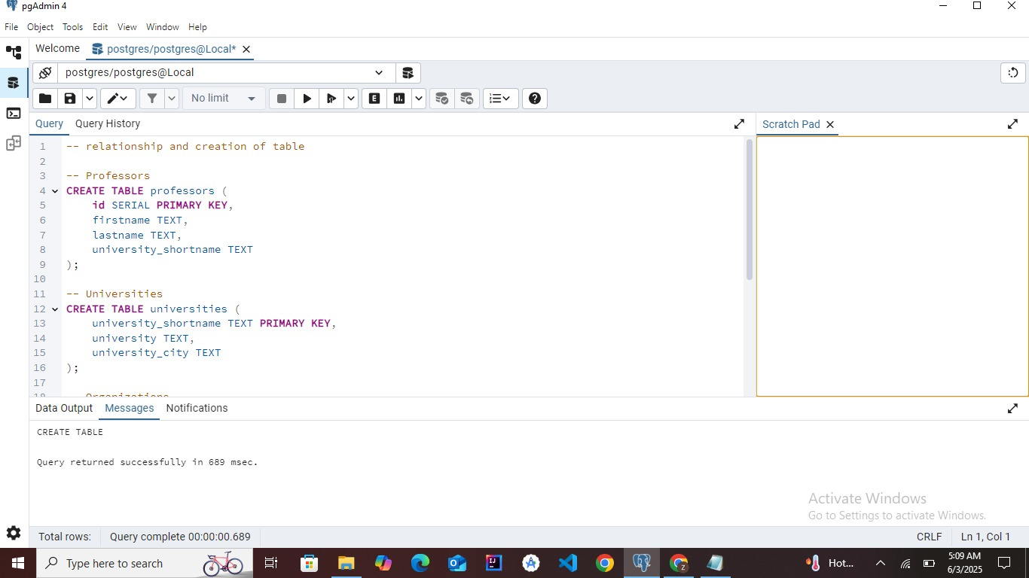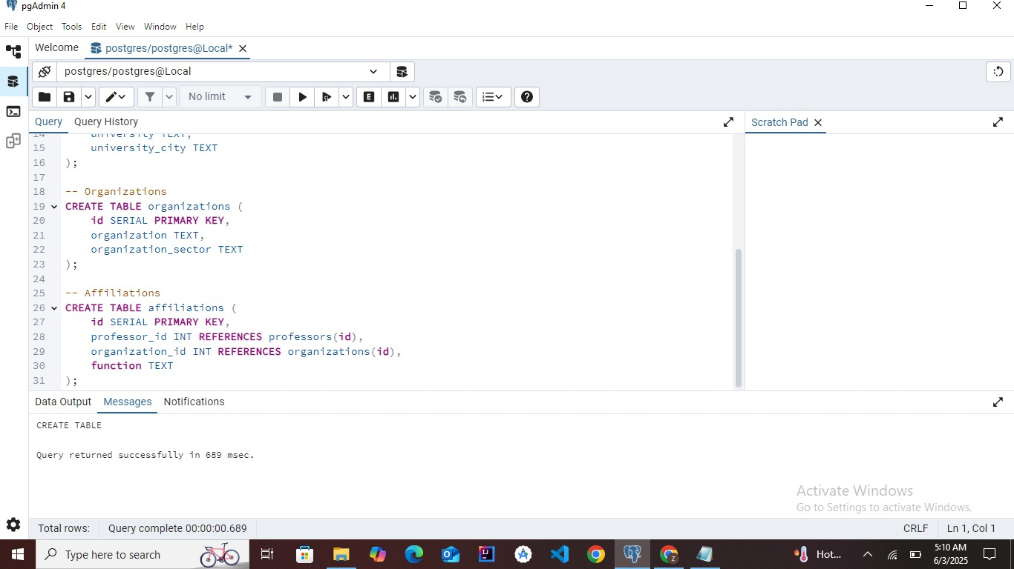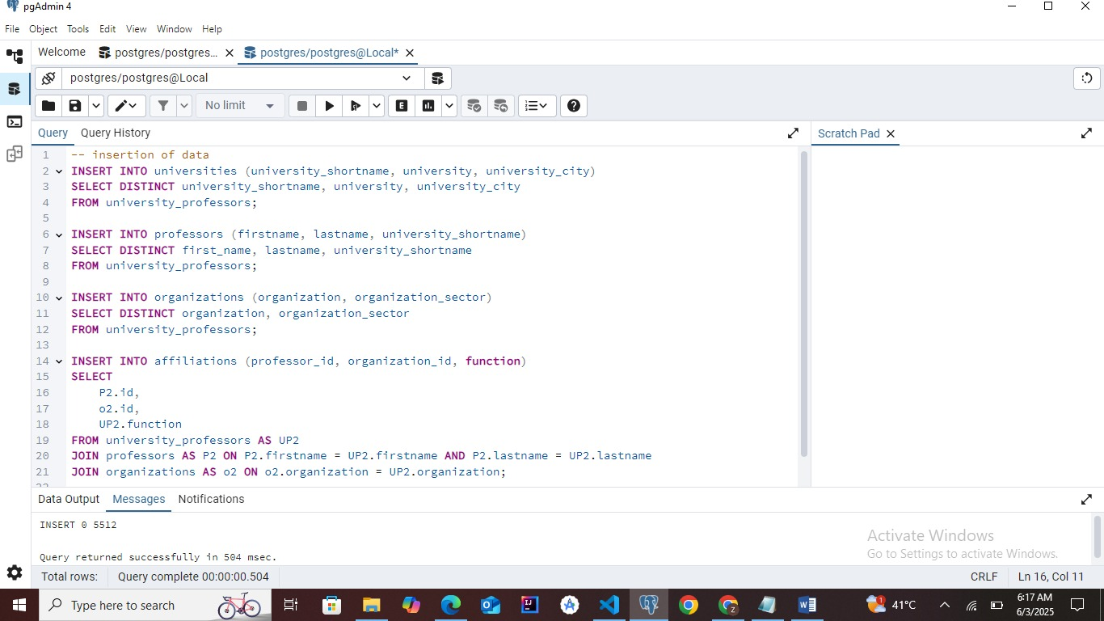

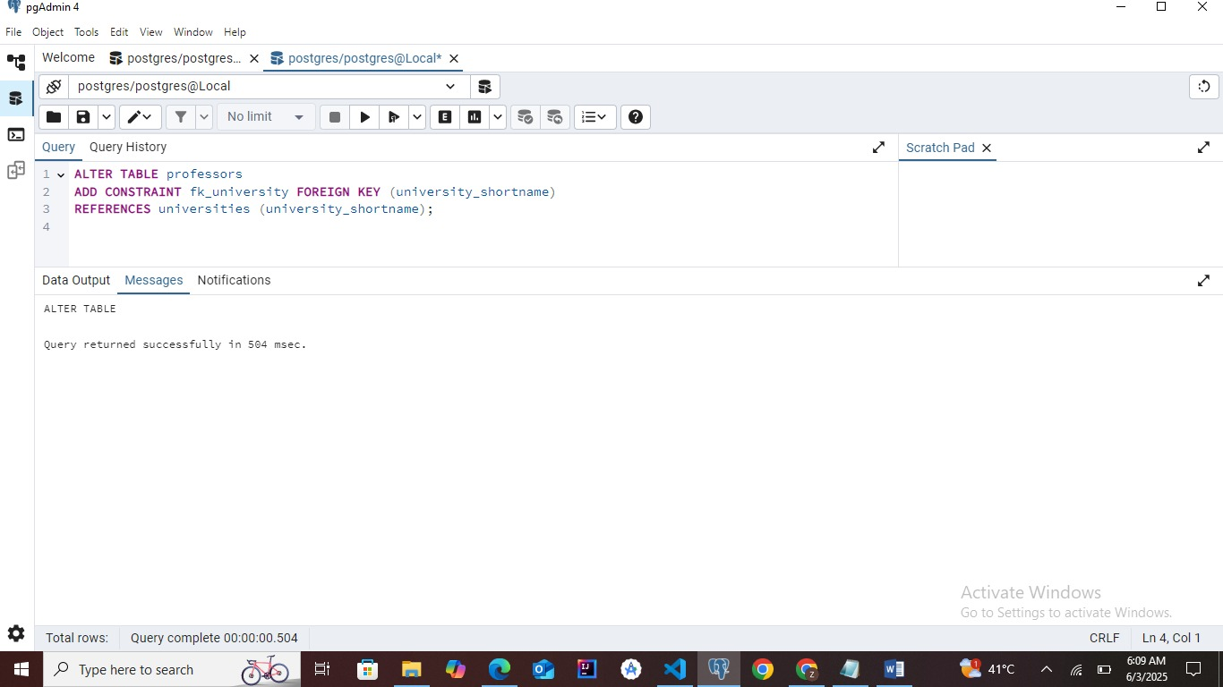

6. Project Files

(Provide gitHub link)

https://github.com/zainabkhan01252/Database_Project_Final